**Emergency vehicle detection**

**Updating the signal**

**Capture Image**

**Sent to server to detect vehicle density**

**Calculating the green signal Dealy**

**Send to server to detect vehicle density**



**Capture Image**

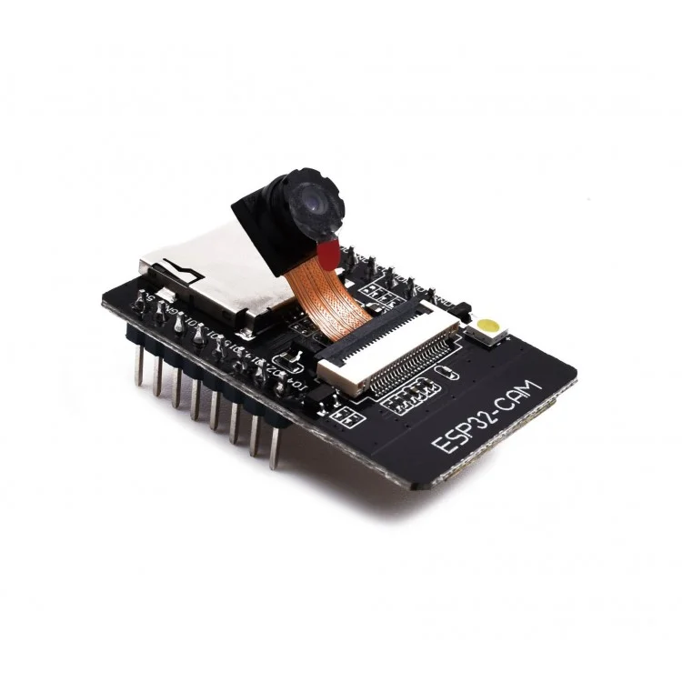

**Calculating the green signal Dealy**



**Updating the signal**

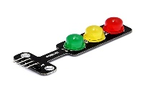



**Emergency vehicle detection**

**System Architecture**

**Use case Diagram**

**Behavioural Design**

**Capture image**

**Traffic Signal**

**Vehicle detection**

**Congestion control**

**Image processing**

**Camera Module**

**Traffic**

**Management**

**AI**

**Emergency Vehicle detector**

**Emergency vehicle**